**TASK 4: Chemistry Year 11: Spectroscopic techniques:**

**Name: ________________________**

1. Consider the **atomic emission spectra** below:

|  |  |
| --- | --- |
| Lithium | http://chemistry.bd.psu.edu/jircitano/Li.gif |
| Sodium | http://chemistry.bd.psu.edu/jircitano/Na.gif |
| Nitrogen | http://chemistry.bd.psu.edu/jircitano/N.gif |
| **UNKNOWN** | http://chemistry.bd.psu.edu/jircitano/Li.gif |

Identify the unknown element, give a reason for your answer **[2 marks]**

__________________________________________________________________________

__________________________________________________________________________

1. **Flame tests and gas discharge tubes:**

In these experiments, you observed different colours.

Explain how these colours occur. Use a **diagram** to support your answer

**[4 marks description, 2 marks diagram ]**

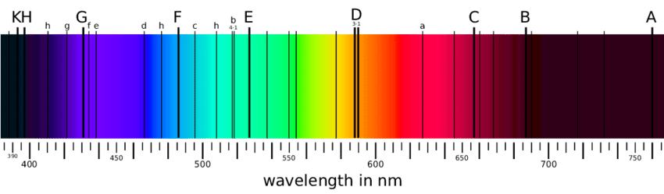

When measuring the light spectrum emitted by the sun an astronomer observes some areas of dark lines. The coloured spectrum is emitted from the main body of the sun and the dark lines occur when the light passes through the atmosphere of the sun.

Explain what is occurring and the information it gives. (5 marks) Include a diagram (1)

1. To determine the concentration of Lead in a sample of water a student made standard lead solutions, and the absorption of each was measured. The results of these, and the absorption from a water sample are shown below:

|  |  |  |
| --- | --- | --- |
| **Sample** | **Concentration (ppm)** | **Absorbance** |
| Blank | 0∙00 | 0∙00 |
| Sample 1 | 1∙00 | 0∙17 |
| Sample 2 | 2∙00 | 0∙34 |
| Sample 3 | 3∙00 | 0∙48 |
| Sample 4 | 4∙00 | 0∙65 |
| Sample 5 | 5∙00 | 0∙83 |
| Unknown Sample | ? | 0∙53 |

* 1. Draw a calibration curve of the data on a fully labelled graph, including a line of best fit. [3]



* 1. Use the calibration curve to estimate the concentration of lead in the unknown sample.

Show working on the graph **[2 marks]**